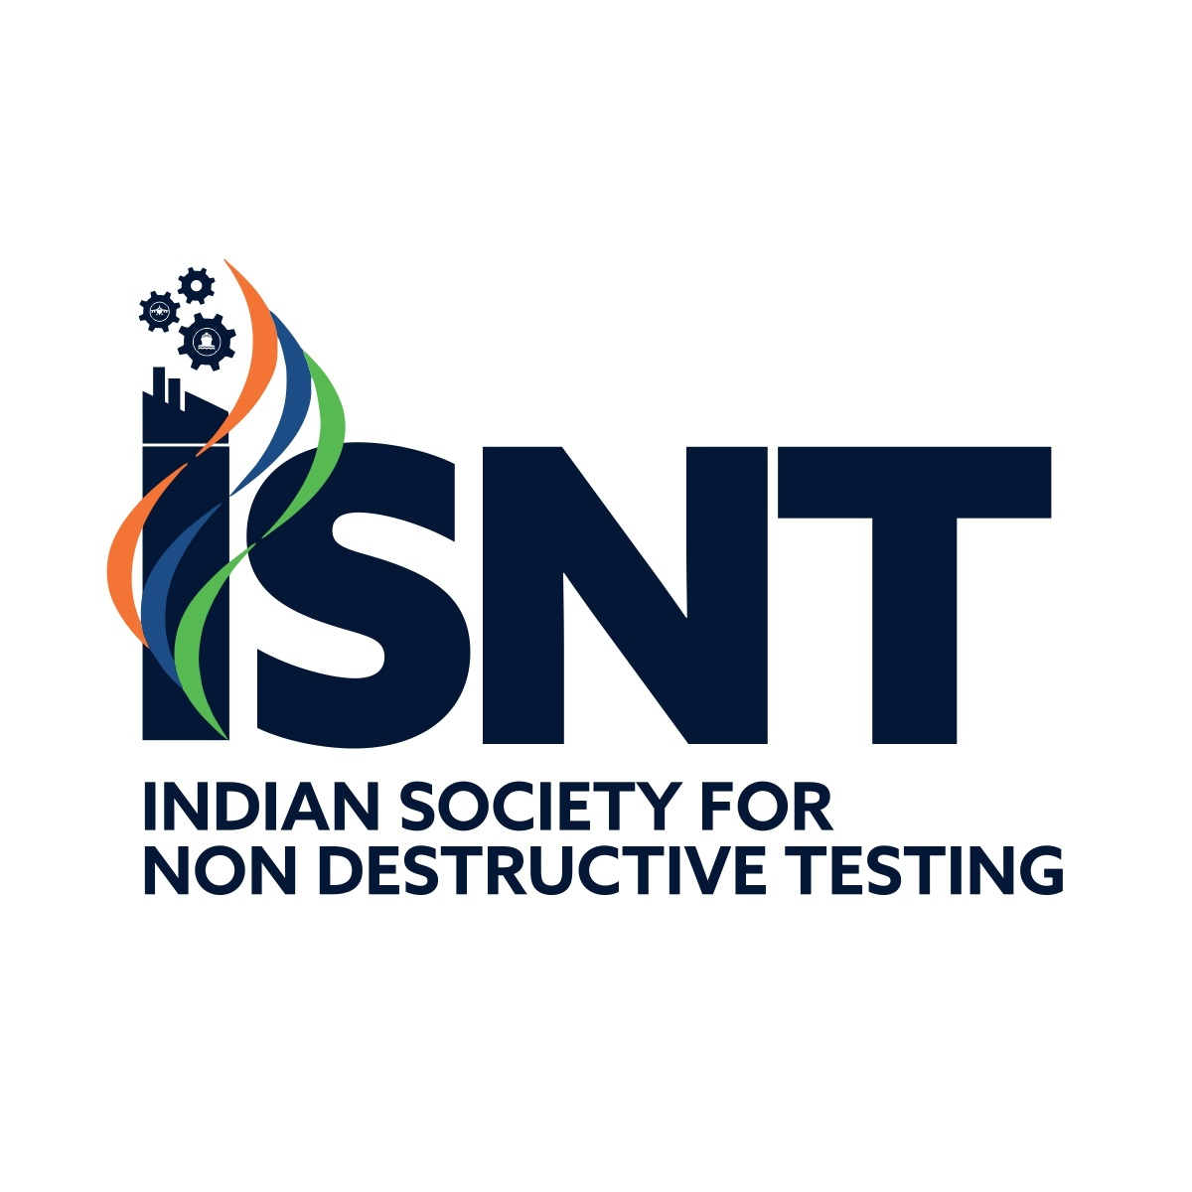
INDIAN SOCIETY FOR NON-DESTRUCTIVE TESTING (ISNT)
APPLICATION FORM
NATIONAL NDT AWARDS — INTERNATIONAL RECOGNITION AWARD
[ Category Specific Form | Category: Global Impact & Leadership | Annexure III E ]
Form ID: ISNT-AF-INT-05 | Revision: 2.0 | SOP Reference: ISNT-SOP-AWR-01
A. AWARD CATEGORY, SCOPE & SUBMISSION ROUTE

Target Category: | ☐ International Recognition Award
Submission Route: | ☐ Route A: Direct Self-Application  ☐ Route B: Nomination by Organisation / ISNT Chapter
Scope of International Work: | ☐ ICNDT / EFNDT / APFNDT Leadership & Committees  ☐ ISO / International Standards Technical Committees & Harmonization  ☐ International Keynotes, Plenaries & Invited Lectures  ☐ Global Industrial / Research Programmes & Joint R&D  ☐ Global Deployment / Licensing / Exports of NDE Technology  ☐ Other International Contribution; Specify: ___________________

B. APPLICANT / NOMINEE DETAILS

Full Name (Capitals): |  | AFFIX PASSPORT SIZE  PHOTOGRAPH HERE
Date of Birth (DD/MM/YYYY): |  | AFFIX PASSPORT SIZE  PHOTOGRAPH HERE
Designation & Organisation: |  | AFFIX PASSPORT SIZE  PHOTOGRAPH HERE
Official Address:
Residential Address:
Contact Details: | Phone:  Email:
ISNT Membership No.:
(ISNT Membership is mandatory and shall be valid from the date of application through 31st Dec 2026).

C. NOMINATOR DETAILS (OPTIONAL — IF APPLICABLE)
(Complete this section only if submitting under Route B: Nomination by Organisation/Chapter)
Nominator Type: | ☐ ISNT Chapter ☐ Honorary Fellow ☐ Company / Industry ☐ R&D / Academic Institute
Name & Address of Body:
Contact Person & Designation: | Email:  Phone:

D. INTERNATIONAL STANDING, LEADERSHIP & ENGAGEMENT ROLES
Note: Focus on sustained leadership, specific roles, and substantive contributions rather than passive membership or activity counts.
International Professional Bodies & Leadership Roles:  (ICNDT, APFNDT, EFNDT, ASNT, BINDT, etc.) | Specify organisation, exact role (Chair/Officer/Member), specific contributions, and duration of leadership:
International Standards Technical Committees:  (ISO, CEN, ASME, ASTM, etc.) | Specify technical committee/working group, candidate's specific role, standards clauses influenced/authored, and duration:
International Keynotes, Plenaries & Invited Lectures: | List high-impact invited keynotes/plenaries, host organisations, countries, topics, and measurable technical impact:
Editorial Roles & International Recognition: | Editorial boards of international journals, peer-review leadership, international honors, fellowships, or awards received:

E. SUBSTANTIVE INTERNATIONAL OUTCOMES & IMPACT ON NDE
Note: Word limits are specified per major criterion (250–400 words max). Up to 2 controlled annexures (max 2 pages total) may be attached. Emphasis must be on verifiable outcomes, technology adoption, and tangible benefits to India and ISNT.
1. Core International Achievements & Outcome Evidence:
(Max 400 words — Detail specific accomplishments, global deployment, tech licensing, or exports of NDE technology)
2. Standards & International Policy Impact:
(Max 350 words — Detail specific ISO/ASME/CEN clauses, standards documents, or harmonization protocols established)
3. International Joint R&D & Collaborative Programmes:
(Max 350 words — Detail candidate's specific role in initiating/leading multi-country research or industrial programmes)
4. Specific Benefits to ISNT & the Indian NDE Community:
(Max 400 words — Detail how international standing elevated ISNT/Indian NDE, created global linkages, or enabled tech transfer)
5. Sustained Global Leadership, Honors & Recognition:
(Max 350 words — Detail sustained leadership over time, international awards, fellowships, and independent global recognition)
6. Future Strategic Vision for Global NDE Advancement:
(Max 350 words — Detail international roadmap, future collaborative plans, and vision for NDE discipline advancement)
7. Role & contributions in Elevating ISNT / Indian NDT on Global Forums:
(Max 300 words — Detail role played and specific contributions made to elevate ISNT and Indian NDE community on Global platform)
Key International Committees, Engagements & Specific Roles:
Sl. | International Event / Forum / Committee / Project | Country / Organisation & Candidate's Specific Role | Measurable Outcome, Policy/Tech Impact & Duration

F. SUPPORTING DOCUMENTS & CONTROLLED ANNEXURES ATTACHED
(Maximum 2 Controlled Annexures, up to 2 pages total allowed)
Sl. No. | Document / Annexure Description (Standards, Patents, Licenses, Testimonials etc.) | Attached (Yes / No)

G. PROPOSED CITATION
(Maximum 75 words — State precisely the principal achievement for which the award is proposed):

H. REFERENCES & CONFIDENTIAL REFEREES
(At least two international referees familiar with candidate's global contributions are recommended)
Sl. No. | Name of Referee | Designation & Organisation | Full Address | Email & Telephone

I. DECLARATIONS & SEPARATE CONSENT
Applicant / Nominee Consent & Declaration:
"I hereby consent to being considered for the National NDT International Recognition Award. I certify that the information submitted in this application is true, correct, and complete to the best of my knowledge. I understand that misleading details may lead to disqualification. I agree that annual confirmation/updates will be required if ISNT considers my application for subsequent cycles."
Nominator Declaration (Required for Route B / Sponsoring Nominator):
Signature of Applicant / Nominee: ___________________  Name:  Date: | Signature & Seal of Nominator (if applicable): _______________  Name & Designation:  Date:
Note on Reconsideration: Applications do not automatically carry forward. Applicants must submit an annual confirmation and updated eligibility/consent form by 31st August for consideration in subsequent cycles.
FOR ISNT OFFICE USE ONLY

Registration No. & Date:
Acknowledgement No.:
Eligibility & Submission Route Verified: | ☐ YES ☐ NO ☐ NOT APPLICABLE
Action / Decision: | ☐ Awarded ☐ Annual Confirmation Received for Next Cycle ☐ Not Recommended

